ML NOTEBOOKS

先导课程：

数学：微积分，线性代数，概率论
编程：Python（会读写修改代码）， 学习对应的库（numpy...）

作业：

Leaderboard：Kaggle or JudgeBoi

1.概念
ML=look for function 找到功能函数

专有名词：
Regression: 输出是一个数值
Classification: 给定选项，输出一个正确选择
Structured Learning：创造结构体
Hyperparameters：在机器学习中自己设定的参数
Overfitting:训练资料上变好，预测资料变差

寻找函数步骤：
1.带有未知参数的函数（称为 Model） 例如 $y=b+wx_{1}$(需要领域知识推测这个函数，后期修正）

$$y=b+C^{T}σ(b+w{x)}_{ }$$

2.从训练数据中定义 Loss（自己设定）（Loss 的函数的输入为 Model 中的未知参数）， 输出代表将这个未知参数的值设定的好不好。Label(真实值)
根据现有的数据，计算函数误差。$e_{N}$（代表每次的误差）=$\left|y-\hat{y}\right|$（$y$代表函数结果，$\hat{y}$代表真实值Loss计算公式如下：

$$L=\frac{1}{N}\sum_{n}{e_{n}}$$

$L$越大则说明现在标定的未知参数不好，越小越好。可以用$θ$表示所有参数，即$L(θ)$
$e_{ }$=$\left|y-\hat{y}\right|$（mean absolute error:MAE） $e_{ }={(y-y ̂)}^{2}$ (mean square error: MSE)

3.优化
目标：$w^{*},b^{*}=arg\min_{w,b}{L}$

函数优化方法：
1.梯度下降法(两个参数则是在一个参数基础上在继续加一个, 参数可用$θ$代替)
(1)假设只有一个参数，随机选取一个初始点$w^{0}$
(2)计算微分$\frac{∂L}{∂w}|_{w=w^{0},b=b^{0}}$计算这个点在error surface的斜率。 如果斜率为负数，则增大$w$；
如果斜率为正数，则减小$w$。 每次变动的$w$的数值由以下公式计算：

$$η\frac{∂L}{∂w}|_{w=w^{0},b=b^{0}}, η:学习速度（自己设定）$$
$$w^{1}←w^{0}-η\frac{∂L}{∂w}|_{w=w^{0},b=b^{0}}$$

当用$θ$表示后：
$$g=\left[\begin{aligned}\frac{∂L}{∂θ_{1}}|_{θ=θ^{0}} \\ \frac{∂L}{∂θ_{2}}|_{θ=θ^{0}} \\ ⋮\end{aligned}\right]$$
$$θ^{1}←θ^{0}-ηg$$

当将 N 个资料划分为 B 个一组的的多组资料，每次只拿一组B拿出来计算 Loss，算出的为$L^{0-\frac{N}{B}}$

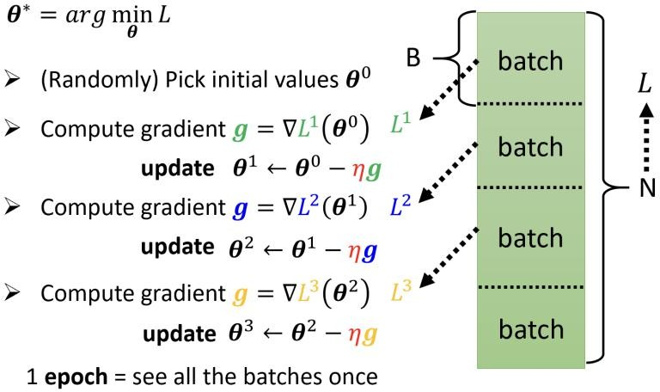

每次的更新(Epoch)=$\frac{N}{B}$

(3)更新新的$w$,继续重复过程。停止的两种情况（1.自己设定次数 2.斜率变为0，可以称为local minimum，error surface中最低点称为 global minimum）

(4)模型优化：根据现有模型就行预测未来情况后，与真实情况进行对比，进一步总结情况，对模型进行优化。

线性模型->弹性模型

分片线性曲线= 常数+ 多个

连续曲线也可以通过曲线上取点构造分片线性曲线
Rectified Linear Unit(ReLU)：$c max\left(0,b+wx_{1}\right)$

Sigmoid Function 的构造，从而达到分片曲线的效果,公式如下：

$$y=c\frac{1}{1+e^{-\left(b+wx_{1}\right)}}=c sigmoid\left(b+wx_{1}\right)$$

其中，改变 $w$则改变斜率，改变 $b$则改变左右，改变 $c$改变高度。

整个曲线可以表达为：
$$y=b+\sum_{i}{c_{i} sigmoid\left(b_{i}+\sum_{j}{w_{ij}x_{j}}\right)}$$

也可以用 ReLU 表达为：
$$y=b+\sum_{2i}{c_{i} max\left(0,b_{i}+\sum_{j}{w_{ij}x_{j}}\right)}$$

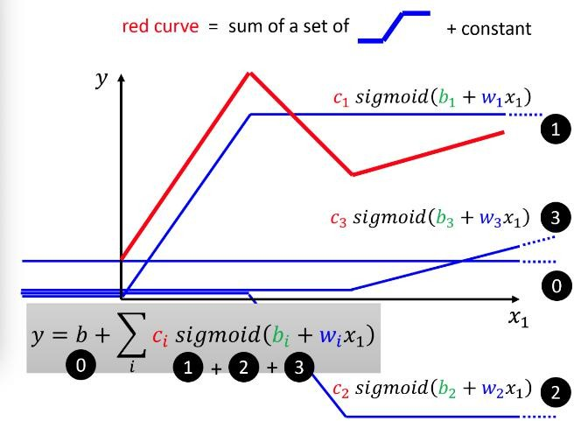

将$b_{i}+\sum_{j}{w_{ij}x_{j}}$带入 Sigmoid,转为线代的如下所示：
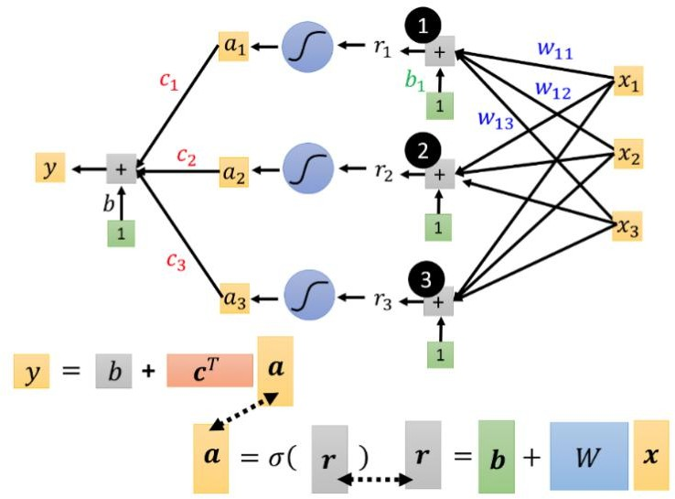

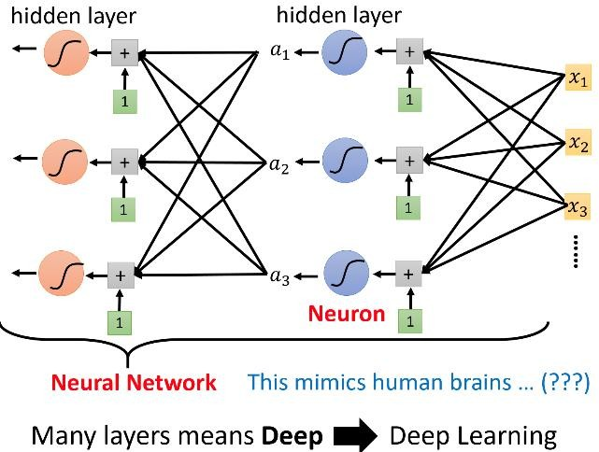
总结： 神经网络，由多层组成就变深度学习

类神经网络问题

Training loss：

(1)model bias: issues about model
(2)optimization issue: can’t find it
Reason: if the training loss of the higher layers model is higher than the lower one, it means the optimization isn’t good, because the flexibility of the model is better than the lower one.
If deeper networks do not obtain smaller loss on training data, then there is optimization issue.

Overfitting: training data loss is lower than that on the testing data loss

Solutions: (1)more training data (2)data augmentation (3)constrained model(less parameters, sharing parameters, early stoping, regularization, dropout)
Mismatch: training and testing data have different distributions.
N-fold Cross Validation: cut training set

Optimization Fails:

(1)Gradient is close to zero: saddle point, critical point, local minimum.
$L\left(θ\right)≈L\left(θ^{'}\right)+{\left(θ-θ^{'}\right)}^{T}g+\frac{1}{2}$ ${\left(θ-θ^{'}\right)}^{T}H\left(θ-θ^{'}\right)$

In the formula, at the critical point, ${\left(θ-θ^{'}\right)}^{T}g=0$, so the $L\left(θ\right)≈L\left(θ^{'}\right)+\frac{1}{2}$ ${\left(θ-θ^{'}\right)}^{T}H\left(θ-θ^{'}\right)$

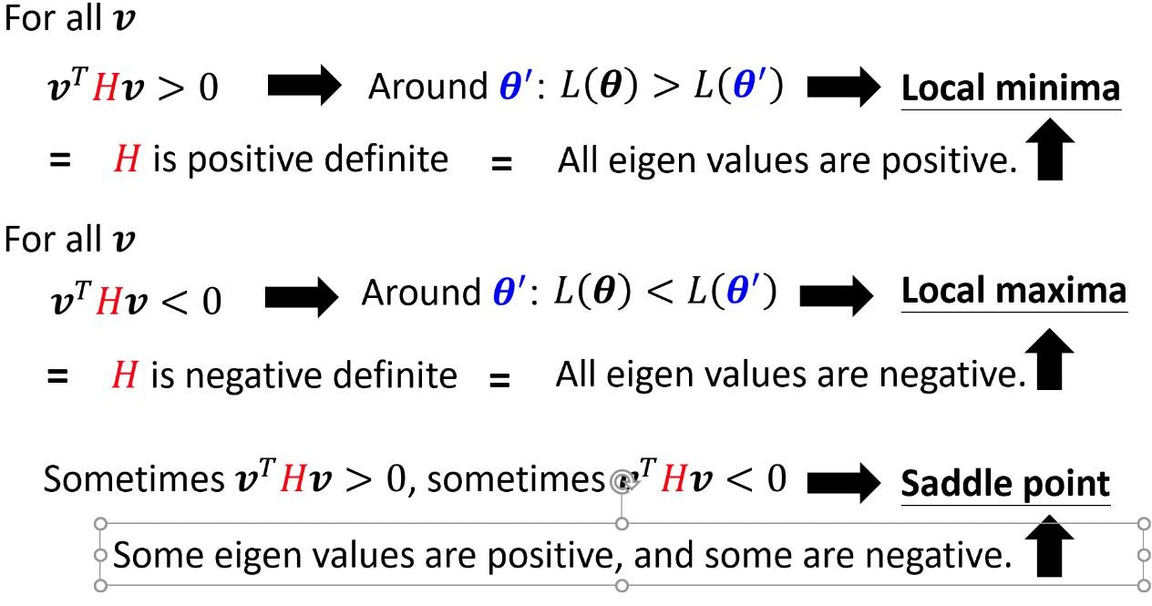
Calculate the eigen values(特征值)

Local minimum: the eigen values are positive

Local maximum: the eigen values are negative

Saddle point: eigen values have negative values and positive values.(for example, $λ_{1}=2,λ_{2}=-2$)

Minimum ratio=number of positive eigen values/numbers of eigen values

(2)The solutions of saddle point
1.Optimization with Batch:
Small batch(noisy, help training): batch size=1 large batch: batch size(powerful)=N(full batch)

 | Small | Large
Speed for one update (no parallel) | Faster | Slower
Speed for one update (with parallel) | Same | Same (not too large)
Time for one epoch | Slower | Faster
Gradient | Noisy | Stable
Optimization | Better | Worse
Generalization | Better | Worse

2. gradient descent + momentum(consider the former movement)
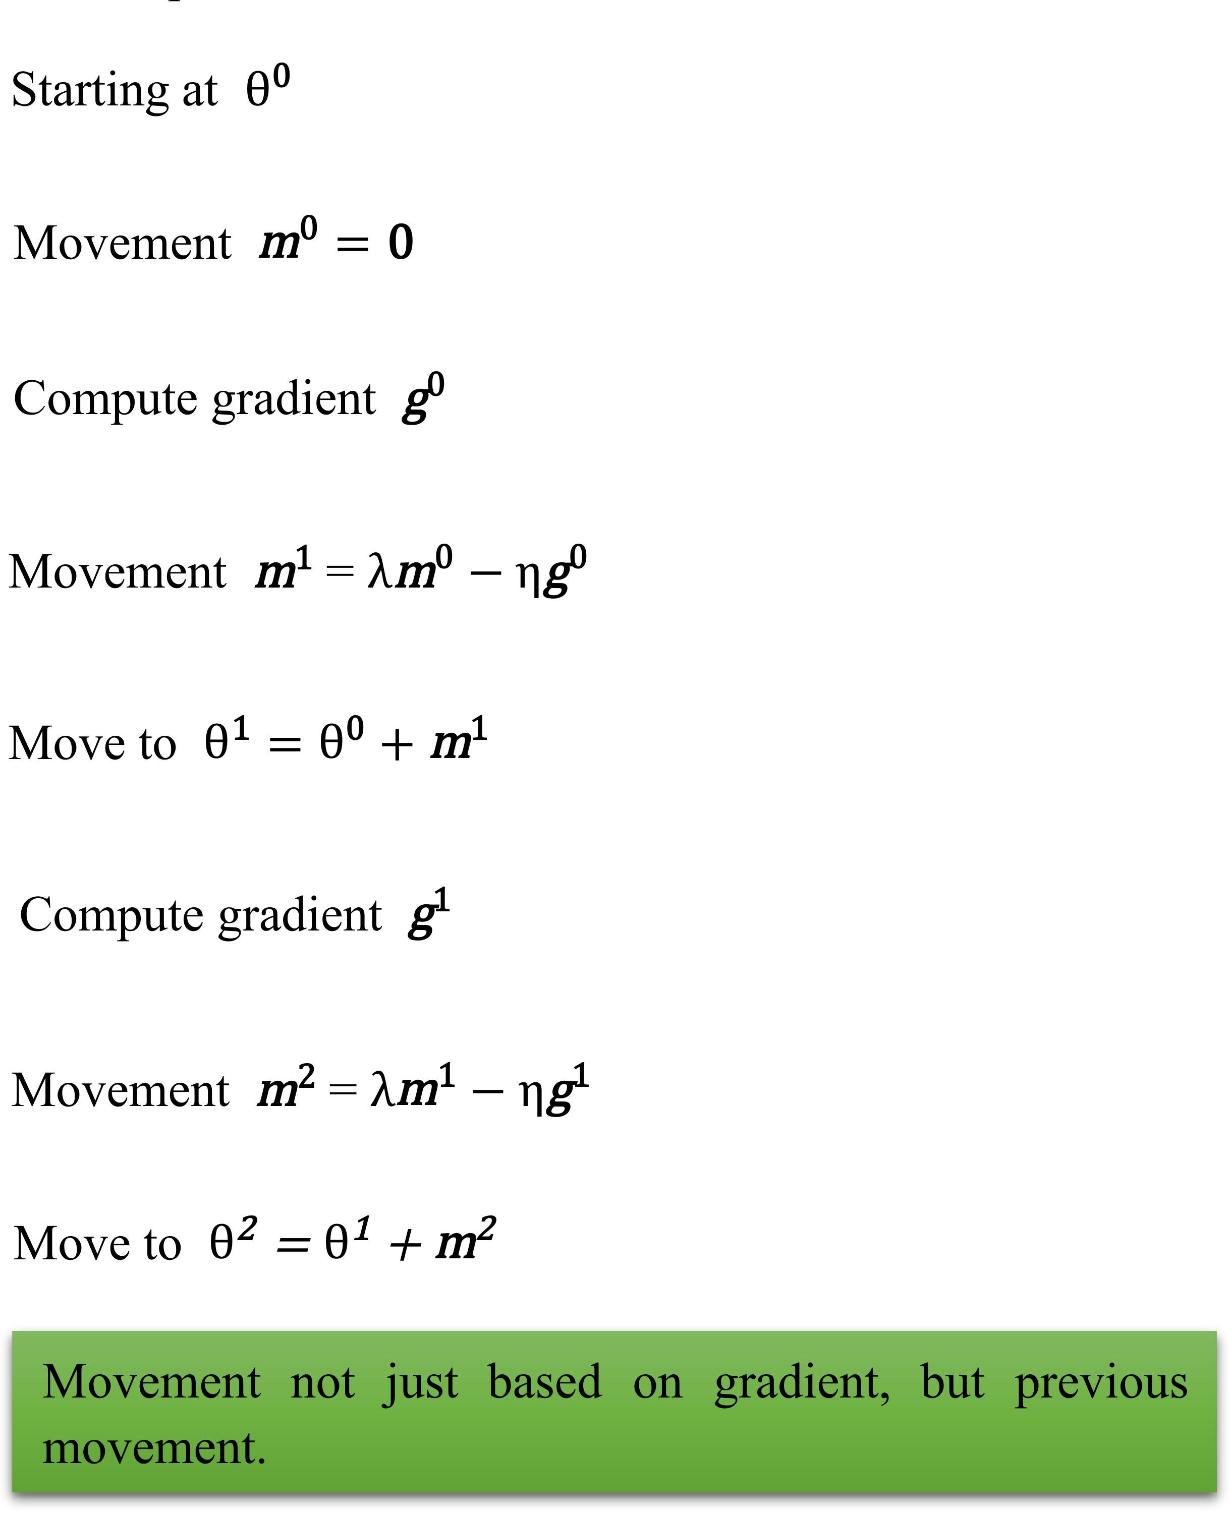
Movement: movement of last, not just based on gradient, but previous movement. Step minus gradient at present

Learning rate: different parameters need different learning rate
Root Mean Square Formulation:

$$θ_{i}^{t+1}←θ_{i}^{t}-\frac{\text{η}}{σ_{i}^{t}}g_{i}^{t}$$
$$σ_{i}^{t}=\sqrt{\frac{1}{t+1}\sum_{i=0}^{t}{{\left(g_{i}^{t}\right)}^{2}}}$$

For example:

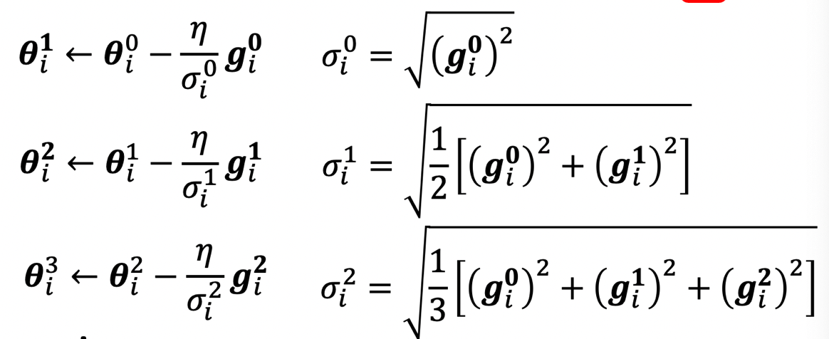

RMS Prop:(set the weight of the calculation of $σ_{i}^{t}$)

$$θ_{i}^{t+1}←θ_{i}^{t}-\frac{\text{η}}{σ_{i}^{t}}g_{i}^{t}$$
$$σ_{i}^{t}=\sqrt{{α\left(σ_{i}^{t-1}\right)}^{2}+\left(1-α\right){\left(g_{i}^{t}\right)}^{2}}$$

Adam: RMS Prop+momentum

Learning Rate Scheduling:
$$θ_{i}^{t+1}←θ_{i}^{t}-\frac{\text{η}}{σ_{i}^{t}}g_{i}^{t}$$

$η_{ }^{t}$ change with the time, there are two methods to change the parameter.
1.learning rate decay
2.warm up

Classification:
Method: one-hot vetor
$$\hat{y}\overset{↔}{e}y^{'}=softmax\left(y\right)$$

Normalize: make all values into 0-1

Soft-max:

$$y_{i}^{'}=\frac{exp\left(y_{i}\right)}{\sum_{j}{exp\left(y_{i}\right)}}$$
$$1>y_{i}^{'}>0$$

$$\sum_{i}{y_{i}^{'} =1}$$
Cross-entropy
$$e=-\sum_{i}{{\hat{y}}_{i}lny_{i}^{'}}$$

Changing the loss function can change the difficulty of optimization

Batch Normalization:
1.feature normalization

CNN(Convolutional Neural Network)

Image Classification:
1.One picture 3-D tensor: number of channel(pixel: Red, Green, Blue), height, width
Tensor vector network input

Simplification1: choose receptive field
1.Typical setting: All channels
kernel size(3*3) stride(movement)
overlap: padding(input 0 or others)

Simplification2: sharing parameters
Notice: two neurons with the same receptive field would not share parameters
1.Typical setting:
Each receptive field has the neurons with the same set of parameters. : filter1,2,…

Benefits of convolutional layer
Convolutional layer(for image)=receptive field+ parameter sharing

Subsampling(缩放): will not change the object
Pooling:-Max pooling(choose the maximum):keep the object unchanged.

Convolutional Layers + pooling: repeat

Self Attention

Vetor set as input

- output: (1)each vector has a label (2)the whole sequence has a label (3)model decides the number of labels itself

- Sequence Labeling
FC: fully-connected
Consider the neighbor

Process of Self- attention(can repeat):

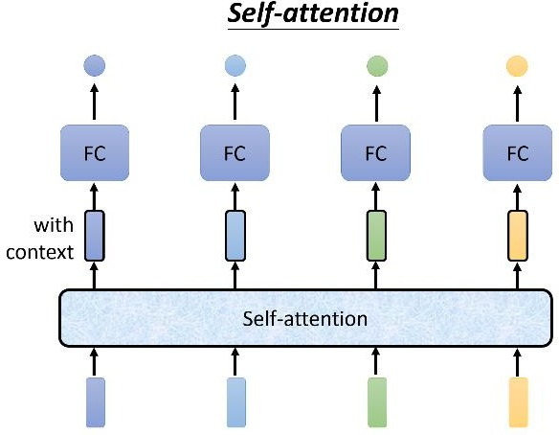

- Consider the whole sequence

- input a vector with the context and the put it into the FC, then we can get the output.

Input of Self-Attention are vectors, it can be the input of Network or the input of a hidden layer.

1.Find the relevant vectors in a sequence:

- Dot-product(priority):

1.calculate $α$
$$α=q∙k$$

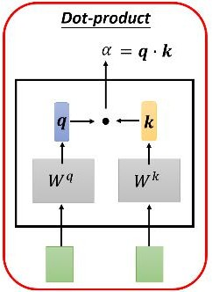

2.calculate Attention score:
$$α_{i,j}=q^{i}∙k^{j}$$
$$q^{1}=W^{q}a^{1}$$
$$q^{i}=W^{q}a^{i}$$
$$k^{2}=W^{k}a^{2}$$
$$k^{i}=W^{k}a^{i}$$

We also need to calculate the attention score with itself, for $α_{1}$, we should calculate $q^{1}$ and $k^{1}$

3.conduct Soft-max:
For instance:
$$α_{1,i}^{'}=exp\left(α_{1,i} \right)/\sum_{j}{exp\left(α_{1,j} \right)}$$

Sketch image:

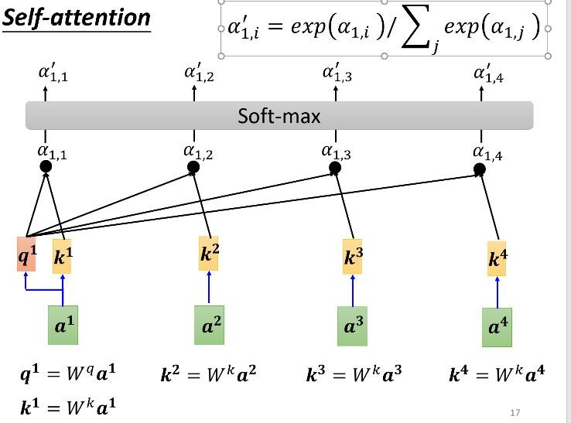

4.extract information from based on attention score(parallel computing)
$$v^{i}=W^{v}a^{i}$$
$$b^{j}=\sum_{j}{α_{j,i}^{'}v^{i} }$$

According to the above formulation, if the attention score is higher, the proportion of this vector of the output will be high.

Matrix:
$$q^{i}(Q)=W^{q}a^{i}=W^{q}[a^{1},a^{2},a^{3},a^{4}…]$$
$$k^{i}(K)=W^{k}a^{i}=W^{k}[a^{1},a^{2},a^{3},a^{4}…]$$
$$v^{i}(V)=W^{v}a^{i}=W^{v}[a^{1},a^{2},a^{3},a^{4}…]$$

$$α_{i,j}=q^{i}⋅k^{j}=[\begin{matrix}k^{1} \\ k^{2} \\ k^{3}\end{matrix}][\begin{matrix}q^{1} & q^{2} & q^{3}\end{matrix}]$$
$$α_{i,j}^{'}(A^{'})\overset{←}{\text{ soft- }max}K^{T}Q$$
$$[b^{1},b^{2},b^{3},b^{4}…](O)=VA^{'}=[v^{1},v^{2},v^{3},v^{4}…]A^{'}$$

Multi-head Self-Attention: different type of relevance

additive

Positional Encoding:
(1)No position information in self-attention (2)each position has a unique positional vector $e^{i}$

Application of Self-attention: NLP, Speech(Truncated Self-attention: just choose some parts), Image, Graph(just need to calculate connected nodes)

Difference between CNN and Self-Attention:
CNN is simplified self-attention, CNN is the Self-attention that can only attends in a receptive field, and Self-attention is CNN with learnable receptive field
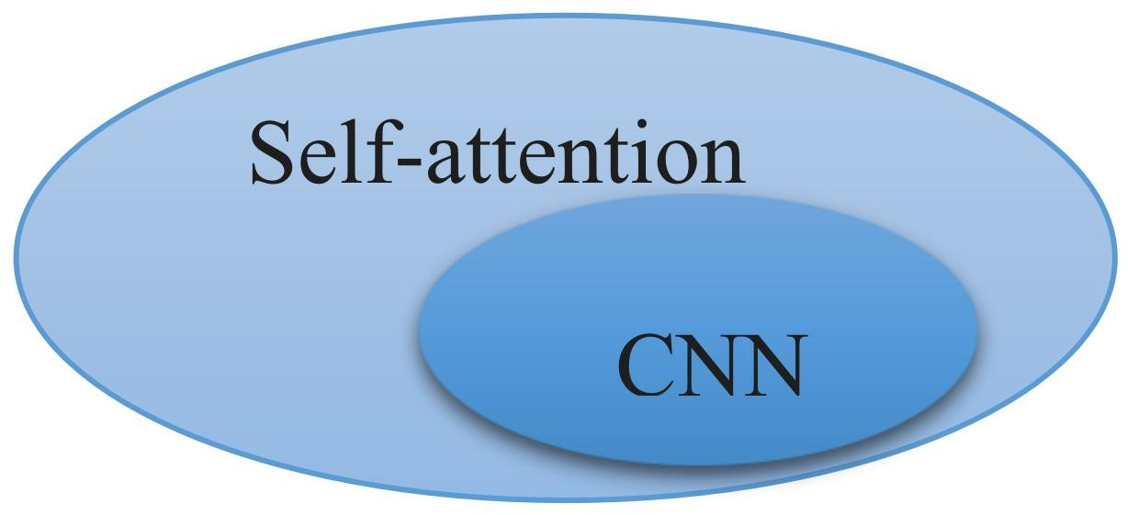

Transformer
It means sequence-to-sequence(Seq2seq) model:input a sequence, output a sequence, the output length is determined by model

Application: text-to-speech synthesis, Chatbot, NLP(input(question)-output(answer)), Syntactic Parsing

Encoder:(self attention)

Many block: each block do self-attention

Image of process:
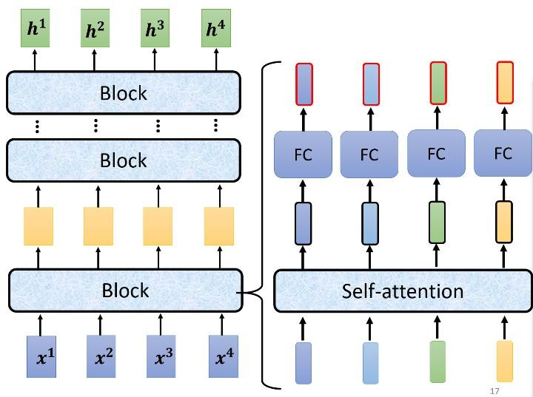

Residual connection: new output=output from self-attention + input

Layer normalization：

$$x_{i}^{'}=\frac{x_{i}^{'}-m}{σ}$$

The whole process of Block:
- Each block do Self-attention
- Do residual connection of output from Self-attention
- Do Layer normalization of the new output
- input the output from layer norm into FC
- do residual connection of the output from FC
- Do Layer Norm of the output from residual connection, then get the output of one block

Image of the process:
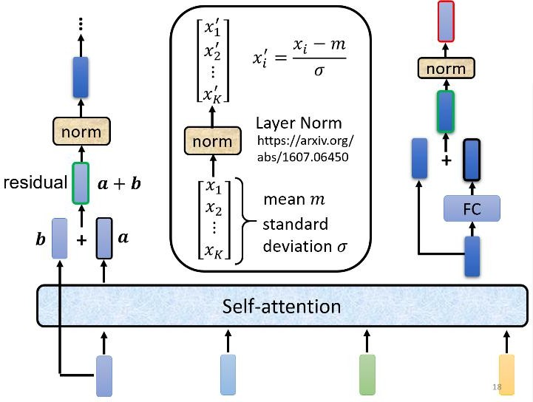

GAN（Generative Adversarial Network 生成式对抗网络）

network as Generator
Input(x + simple distribution z)->Network->y(complex distribution)
Notice: (1)distribution must be simple so that we can sample from it. (2)when input a value to network, we will get a new value of z from distribution.

- the reason for distribution
For tasks need ‘creatively’(the same input has different outputs). For example, we can apply for drawing, chatbot.

- unconditional generation
Low-dim vector+ normal distribution(can choose different distribution, as soon as sample, because generator can choose one) -> generator -> high-dim vector

- Discriminator(neural network)
Input a image and output the scalar(larger means real, smaller means fake)

- basic idea of GAN
NN Generator-> Discriminator (find the difference from the true image and the output)
(it means Generator need to improve itself so that it can make Discriminator can not find the difference, at the same time, Generator and Discriminator will evaluate themselves with iterations.)

- algorithm
(1)initialize generator and discriminator
(2)in each training iteration:
Step1: fix generator and use it to output some image with randomly sample input, then use these output match real images which from database, so that we can update the Discriminator(as classification or regression).
Step2: fix Discrimination and update Generator(train generator can use gradient descent)
Step3: repeat Generator and Discriminator alternatively

- Theory:
$$G^{*}=arg\min_{G}{Div\left(P_{G},P_{data}\right)}$$

Divergence between distributions $P_{G}$and $P_{data}$make it as soon as possible.

Step: The Discriminator give the data sampled from $P_{G}$ the lower score and give that from $P_{data}$ the higher score.

Optimization:
Training:

$$D^{*}=arg\max_{D}{V\left(D,G\right)}$$

objective function for Discriminator:
$$V\left(G,D\right)=E_{y∼P_{data}}\left[logD\left(y\right)\right]+E_{y∼P_{G}}\left[log\left(1-D\left(y\right)\right)\right]$$

Small divergence means Discriminator is hard to discriminate, so the value of $\max_{D}{V\left(D,G\right)}$ is small, by contrary, if the divergence is large, the value of $\max_{D}{V\left(D,G\right)}$ will be large, so the formulation can be changed as follows:

$$G^{*}=arg\min_{G}{Div\left(P_{G},P_{data}\right)}$$

Tips for train GAN: WGAN
1.js divergence is not suitable
Reason: (1)nature of data (2)sampling (3) in most cases, $P_{G}$ and $P_{data}$ are not overlopped

JS divergence is always log2, if two distributions do not overlop.

Wasserstein distance:
Using Many possible “moving plans” and with the smallest average distance to define this distance.

Evaluate Wasserstein distance between $P_{G}$ and $P_{data}$

$$\max_{D∈1-Lipschitz}\left\{E_{x\sim P_{data}}\left[D\left(x\right)\right]-E_{x\sim P_{G}}\left[D\left(x\right)\right]\right\}$$

D has to be smooth enough function.

Improved WGAN -> Gradient Penalty: keep the gradient close to 1 Spectral Normalization -> keep gradient norm

Self-Supervised Learning（自监督学习）
Without Label

Transformer Encoder: BERT

Process of BERT:
1.randomly masking some tokens(eg.changing one word or hide one word)
Next sentence Prediction(not helpful)

2. application: Downstream Tasks
Use Fine-tune(微调)

Process:
Data $\underset{→}{self-supervised laearning}$(pre-train) BERT$\overset{→}{fine-tune}$Downstream Tasks(model for task1, model for task2 ….)

GLUE(General Language Understanding Evalution)

USE BERT:
Case1: input sequence, output: class, Example: sentiment analysis(BERT use parameters from trained model because it will be better than randomly parameters)

Case2: input sequence, output: same as input, Example: POS tagging

Case3: input: two sequence, Output: a class Example: Natural Language Inference

Case4: Extraction-based Question Answering
Document: $D=\left\{d_{1},d_{2},⋯,d_{N}\right\}$
Query:$Q=\left\{q_{1},q_{2},⋯,q_{M}\right\}$
Answer:$A=\left\{d_{s}, ⋯,d_{e}\right\}$
Input D,Q into QA Model, then output two integers(s,e): it means s, e represent the location of correct word in the article, s represents the location of first word of correct answer in the article and e represents the last word.

Training BERT is challenging, because it cost much time and it needs enormous data.

Training a seq2seq model: using text infilling(eg.delete a word, permutation, rotation)

